Minor Project (BTCS607N) Weekly Progress Report (Week-5)
Project Title: Vaari - Crop Water Footprint Information App
Phase 3 — Object-Oriented Design
Goal: Model the interaction between objects using a sequence diagram for the main crop search flow in Vaari.
1. Introduction
- Week 5 focuses on interaction modeling.
- This week explains how the different objects of the Vaari application communicate with each other over time.
- The main deliverable for this week is the sequence diagram.
2. Sequence Diagram
- The sequence diagram shows the order of messages between the user interface, ViewModel, Repository, API service, and local storage.
- For Vaari, the diagram typically starts with the user entering a crop name and ends with the app displaying the water footprint result.
- If the crop is found, the system fetches the crop data, shows the result, and saves the search history.
- If the crop is not found, an error message is shown.

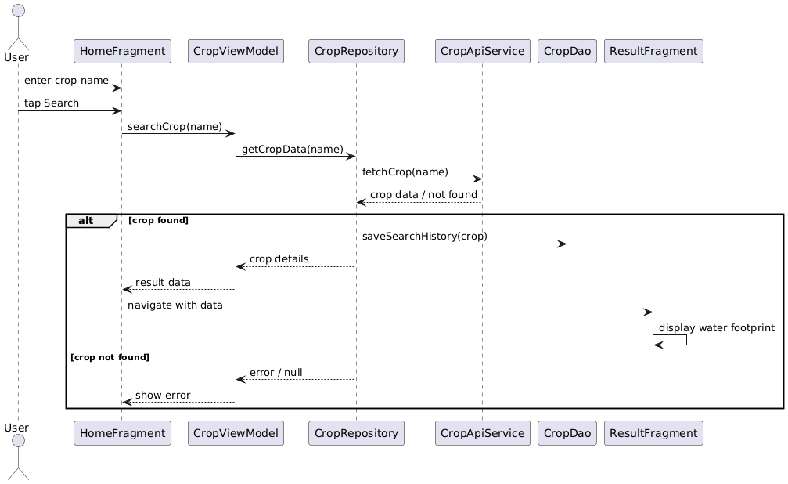
3. Main Interaction Flow
- User enters crop name in the Home screen.
- HomeFragment sends the request to CropViewModel.
- CropViewModel forwards it to CropRepository.
- CropRepository asks CropApiService for crop data.
- The result is returned to the UI and displayed on the Result screen.
- Search details are stored in SearchHistoryEntity through CropDao.
4. Scope of Week 5
- Week 5 is limited to communication modeling between objects.
- Detailed class attributes or package organization are not the focus here.
- The sequence diagram is used to understand runtime behavior.
5. Deliverables
- Sequence diagram for crop search flow.
- Explanation of object interactions.
- Communication flow between UI and backend components.
6. Expected Outcome
- A clear understanding of how the app works at runtime.
- A proper message flow for the search operation.
- A foundation for later detailed design and implementation.
7. Team Roles
- Team members will collaborate on interaction mapping and diagram preparation for the crop search flow.

Mentor Signature ___________________ Project Guide Signature _____________________

